

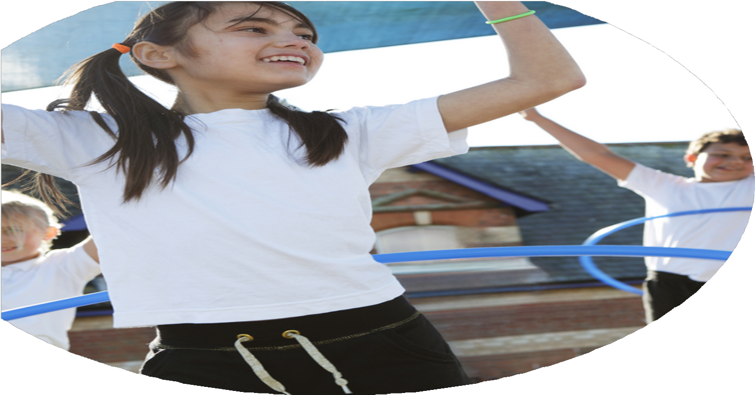
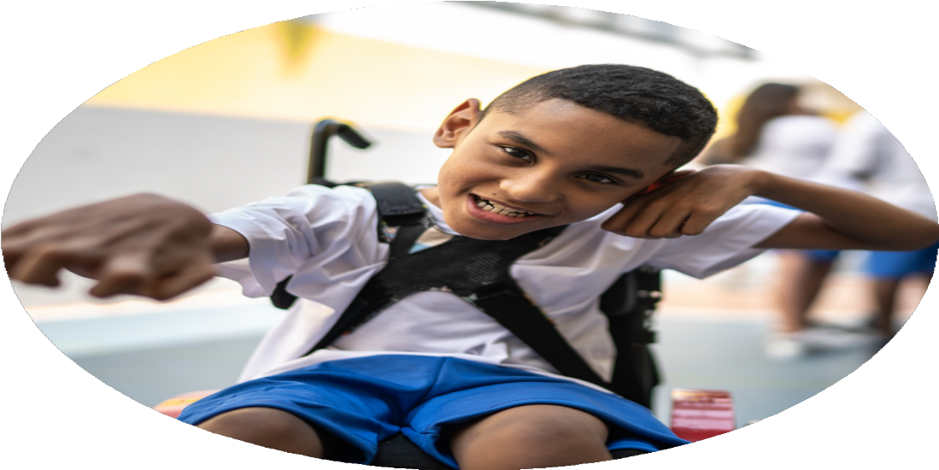




PE Funding

Evaluation Form

Commissioned by

Created by

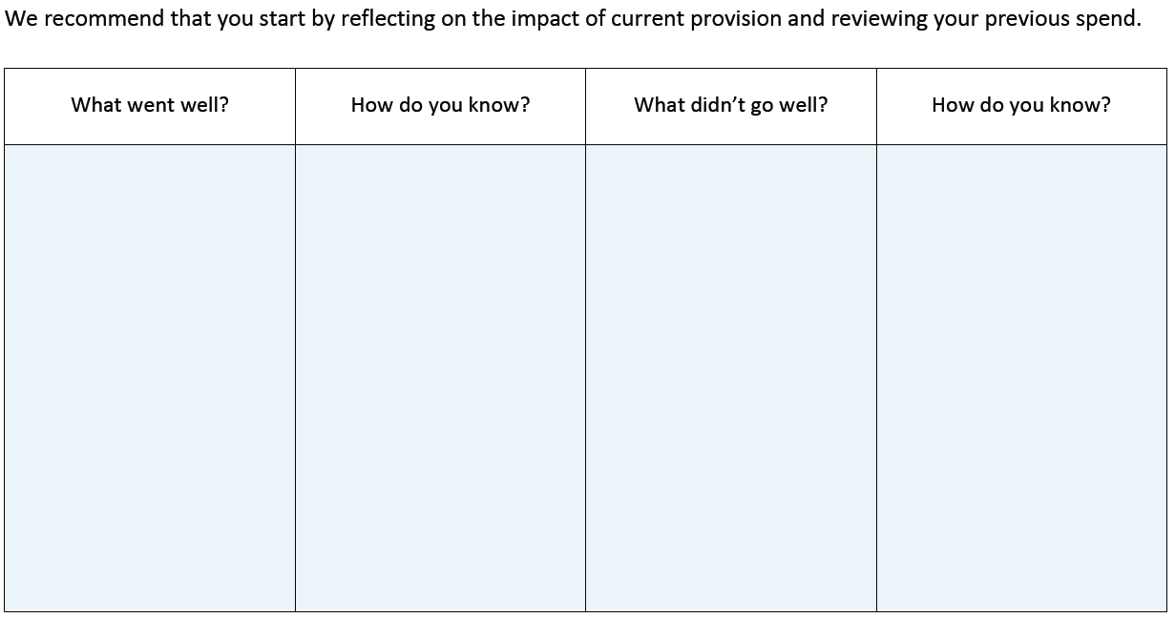
• Limited pathways and progression for gifted and talented pupils.
• Need to further encourage lifelong physical activity habits.
• Sustainability of structured active playtimes is affected by lack of respect/responsibility for equipment.
• Impact on fitness levels, wellbeing, and attitudes towards activity is not consistently tracked.
• Timetabled PE may not meet the recommended 2 hours per week.
• Implementation of the PE curriculum requires strengthening (Ofsted feedback).
• Swimming provision does not fully meet national curriculum expectations.
• Staff confidence in teaching a wide range of activities (e.g., OAA, athletics, striking & fielding) needs improvement.
• PE progression tracking is not consistently evidenced across all year groups.
• Leadership opportunities are mainly limited to Year 5 pupils.
• Parental involvement and community links could be further developed.
• Engagement of less active pupils, needs improvement.
• Cross-curricular links in PE are inconsistently applied.

• Pupil voice surveys and feedback on lessons, clubs, and events.
• Positive Ofsted feedback from the PE deep dive (noting strong intent and curriculum design).
• Increased staff confidence reported following CPD and specialist input.
• Increased pupil participation rates in extra-curricular clubs, including new and non-traditional sports.
• High levels of pupil engagement observed during playtimes, lunchtimes, and PE lessons.
• Attendance and success in inter-school competitions and School Games events.
• Parent feedback on special events (e.g., Sports Day, Sports Week, athlete visits).
• EYFS observational evidence of increased confidence and skills in early physical development.
• Reduced numbers of pupils inactive at playtimes due to structured provision and new equipment.
• Case studies of SEND pupils demonstrating improved inclusion, confidence, and achievement in PE.
• Visible celebration of sporting achievement in assemblies, displays, and newsletters.

• Broad, balanced, and progressive PE curriculum.
• Strong intent highlighted by recent Ofsted deep dive and clear progression across year groups.
• Specialist coaches and ongoing CPD enhanced staff confidence.
• Inclusive and engaging whole-school events (Sports Days, Sports Week, athlete visits).
• Curriculum developed resilience, teamwork, leadership, and communication skills.
• Well-maintained facilities and high-quality equipment.
• Clear assessment and tracking monitored pupil progress and participation effectively.
• Pupil voice influenced clubs and extra-curricular provision, increasing engagement.
• Active playtimes, playground leaders, and wider equipment offerings reduced inactivity and promoted daily activity.
• EYFS and KS1 pupils developed foundational physical skills through initiatives like Balanceability and Bikeability.
• Participation in competitions and non-traditional sports.
• Investment in resources and CPD created a sustainable legacy of improved teaching and provision.

• Participation data shows growth but some pupils, especially less active remain under-engaged.
• Observations reveal structured playtimes are better but equipment misuse affects sustainability.
• Baseline and exit measures for fitness, wellbeing, and attitudes are not consistently in place.
• Timetable audits indicate most year groups do not receive the recommended 2 hours of PE per week.
• Ofsted feedback highlighted strong intent but inconsistent implementation across staff and cross-curricular links.
• Swimming outcomes show a proportion of Year 6 pupils do not meet national curriculum expectations.
• Assessment records show inconsistent progression tracking across year groups.

What are your plans for 2024/25?

Intent
How are you going to action and achieve these plans?

Implementation
• Provide a broad and balanced curriculum that develops fundamental movement skills, physical literacy, and a wide range of sports, including traditional and non-traditional activities building on the school’s existing strong offer increasing to 2 hours a week.
• Ensure progressive skill development across all year groups so pupils build on prior learning, while addressing gaps in tracking and assessment to make progression consistently visible.
• Engage all pupils in physical activity, including less active children and pupils with SEND, by offering inclusive lessons, structured playtimes, varied extracurricular clubs, and leadership opportunities beyond Year 5.
• Encourage lifelong physical activity habits through increased opportunities for independent, active play, active travel (Bikeability/Balanceability), and diverse club offerings to sustain engagement beyond school.
• Support high-ability and gifted pupils by strengthening pathways to external clubs, competitions, and tailored skill development sessions to ensure progression for talented pupils.
• Develop resilience, teamwork, leadership, and communication skills through PE lessons, playground leadership, competitions, and whole-school events like Sports Day and Sports Week, expanding leadership roles across KS2.
• Maintain high-quality experiences through specialist coaches, CPD for staff, well-maintained facilities, and a safe environment, building on the school’s current strengths in staff development and equipment provision.
• Promote cultural capital and aspiration by exposing pupils to sporting pathways, visiting athletes, celebrations of achievement, and engagement with local clubs and community sport.
• Improve outcomes in swimming and fitness by ensuring all Year 6 pupils meet national curriculum swimming standards and introducing consistent monitoring of fitness levels, wellbeing, and attitudes towards activity.
• Embed a culture of respect and responsibility for equipment and active spaces, ensuring sustainability of structured playtimes and active sessions across the school.

• Map 2-hour PE week across all year groups, ensuring a balance of: Traditional sports, non-traditional sports and fundamental movement skills with the use of the PE Hub.
• Provide training to all staff on: delivering progressive skill lessons and accurate assessment and tracking. PE Lead to review assessment data and progression records each term.
• Playground leaders in Years 4–6 to run games and activities. Rotate activities weekly to maintain engagement. Create a weekly timetable.
• Offer a variety of clubs targeting different interests and abilities
• Identify pupils who are least active and provide small group activities at lunch and a mentoring or buddy system with more active peers.
• Track participation via registers for clubs, lunchtime activities, and lessons.
• Collect pupil voice feedback termly on engagement, enjoyment, and barriers to participation.
• Continue and expand Bikeability and Balanceability for KS1 and KS2 pupils.
• Maintain a talent register updated termly. Strengthen relationships with local sports clubs, academies, and community programs and provide information to parents. Encourage participation in School Games.
• Use Sports Week, and intra-school competitions to foster teamwork, resilience, and leadership.
• Continue to work with Cre8tive and SJD coaching to upskill staff, allowing them to deliver higher-quality lessons in the future. Collect staff feedback.
• Conduct termly audits of indoor and outdoor PE facilities and equipment. Rotate or replace equipment to keep activities fresh and engaging.
• Invite local or professional athletes to lead workshops, assemblies, or lessons. Focus on stories of resilience, teamwork, and career pathways in sport.
• Maintain achievement assemblies. Use “Hall of Fame” displays to celebrate pupils’ successes in school and external competitions. Share achievements in newsletters, website, and social media to raise profile.
• Identify pupils who have not met standards in swimming in previous years and provide catch-up sessions in small groups.
• Introduce a check-in/check-out system for playground and PE equipment. Teach expected behaviours during lessons and playtimes, e.g., handling equipment safely and returning items after use. Track incidents of misuse and celebrate positive behaviours.

What impact/intended impact/sustainability are you
expecting?
How will you know? What evidence do you have or
expect to have?
• Pupils access 2 hours of high-quality PE weekly with a broad, balanced, and progressive curriculum, improving physical literacy and skill development. Long-term planning framework in place; once mapped, can be reused annually with minimal updates.
• Staff confidence and expertise increase through training and specialist coaching, ensuring consistent, high-quality delivery and accurate assessment. Upskilled staff retain knowledge, reducing future reliance on external providers.
• Active playtimes & varied clubs boost engagement, inclusion, and enjoyment, particularly for less active and SEND pupils. Rotating leadership roles and termly feedback embed a culture of pupil ownership, ensuring ongoing engagement. Broad and varied clubs create inclusive habits; partnerships with external providers and community clubs sustain opportunities.
• Tracking and pupil voice provide clear evidence of participation, identify barriers, and shape provision to meet pupil needs.
• Programmes like Bikeability, Balanceability, and WOW promote lifelong activity habits and active travel. Habits formed in younger years encourage lifelong active travel; programmes can be run annually at low cost.
• Gifted and talented pathways strengthened through talent registers, competitions, and links with clubs and community sport. Registers and data systems establish a consistent cycle of monitoring, informing future planning and intervention.
• Whole-school events (Sports Week, intra-school competitions) foster resilience, teamwork, leadership, and pride. Annual fixtures build tradition, school pride, and resilience; easily embedded into the school calendar.
• Facilities, equipment, and resources are maintained and refreshed, ensuring safe, engaging provision. Regular audits and rotation ensure longevity and safety of resources; budget planning supports replacement.
• Visits from athletes & role models raise aspiration, resilience, & awareness of sporting careers. Celebrations and recognition raise the profile of PE and increase motivation. Ongoing partnerships and low-cost recognition strategies (assemblies, Hall of Fame) keep aspirations high year on year.
• Swimming catch-up helps more Year 6 pupils achieve statutory requirements. Annual targeted support ensures sustained compliance with NC standards.
• Systems embedding respect and responsibility for equipment promote sustainability and positive behaviours. Check-in/check-out routines and behaviour expectations become embedded into school culture, reducing equipment loss.

• PE timetables showing 2 hours per week across year groups.
• Lesson plans and schemes of work from PE Hub.
• Staff training records, CPD evaluations, and feedback forms.
• PE Lead’s termly monitoring notes, learning walks, and assessment reviews.
• Assessment and tracking data showing progression of skills over time.
• Registers for clubs, lunchtime activities, and competitions (including SEND/least active pupils).
• Pupil voice surveys and feedback summaries (termly).
• Photographs, videos, and displays showcasing participation in lessons, clubs, and events.
• Records of leadership timetables and pupil leader reflections.
• Talent register updated termly.
• School Games participation data.
• Letters/communication with parents signposting external clubs.
• Certificates, results, or reports from inter- and intra-school competitions.
• Bikeability and Balanceability attendance records.
• Sports Week programmes, schedules, and pupil evaluations.
• Records of athlete visits (photos, assembly notes, pupil quotes).
• Celebration evidence: assemblies, “Hall of Fame” displays, newsletters, website/social media posts.
• Termly audit reports of facilities and equipment.
• Swimming data showing % of Year 6 achieving NC standards.
• Records of catch-up swimming sessions.

What impact/sustainability have you seen?
What evidence do you have?
• PE timetables showing 2 hours per week
• Curriculum overview showing the breadth of sports and activities
• FS1–Y6 progression document
• PE assessment/tracking data
• Pupil voice/questionnaires
• Club registers and participation figures
• SEND participation evidence
• 100% FS1/FS2 Bikeability/Balanceability participation
• Children's University participation records
• Playground leader rotas
• Leadership training records
• All pupils achieving Level 1 leadership
• 60 pupils involved in Sports Week leadership
• 142 pupils participating in intra-school competitions
• Sports Day participation records
• School Games participation/results
• Gold School Games Award
• Photographs of activities, leadership and inclusive provision
• Specialist coach records
• Staff CPD records
• Pupil feedback from Martin Norris's visit
• Swimming assessment data
• Evidence of the new free swimming provision planned for next year
• Playtime equipment timetables
• Playtime observations
• Equipment audits

Broad and balanced curriculum: Two hours of high-quality PE is now timetabled across the school, providing pupils with a broad range of traditional and non-traditional activities. Sustainable through established curriculum planning and timetabling.
Progressive skill development: The FS1–Y6 progression document has been updated with clear progression for every unit, supporting consistency and building on prior learning. Provides a sustainable framework for staff planning and assessment.
Engagement and inclusion: All pupils access active play, leadership and a range of extracurricular opportunities, with inclusive activities such as archery, kinball and gaga ball broadening participation. Structured provision and pupil leaders help sustain engagement.
Lifelong physical activity: All FS1 and FS2 pupils completed Bikeability/Balanceability, while the introduction of Children's University encourages participation beyond the curriculum. Builds positive activity habits from an early age.
Leadership and personal development: Leadership training has expanded to Years 3–5, with all pupils accessing at least Level 1 and 60 pupils taking leadership roles during Sports Week. Playground leaders also support KS1. Develops a sustainable pupil-led culture of activity, responsibility and teamwork.
Competition and participation: 142 pupils participated in intra-school School Games competitions and all pupils took part in Sports Days. Ensures competition is accessible to a wide range of pupils rather than only the most able.
Quality and aspiration: The school achieved the Gold School Games Award and pupils benefited from a visit from Paralympic athlete Martin Norris. Raises aspirations and reinforces the school's commitment to high-quality, inclusive sport.
Swimming: Safe-water swimming and self-rescue increased from 63% to 83%, despite a small reduction in 25m and stroke attainment. Free additional swimming lessons planned for next year provide a sustainable response to identified gaps.
Active play and responsibility: Timetabled equipment use and playground leadership have created greater structure and ownership during playtimes. Reduces reliance on adults and supports long-term sustainability of active play.

