SUBJECT MUSIC Y1-Y6
KEY STAGE 1 |  | LOWER KEY STAGE 2 |  | UPPER KEY STAGE 2
End of Y1 expectations | End of Y2 expectations | End of Y3 expectations | End of Y4 expectations | End of Y5 expectations | End of Y6 expectations
Performing, singing and playing
- play sounds and silence using untuned instruments  - Sing simple songs, chants and rhymes with a small range (mi-so)  - Perform word-pattern chants  - mimic teacher to copy holes on a recorder A and C (Recorder Boppers Get Rapping/ I’m easy) | - create sounds and silence using untuned instruments and conduct a peer when to start and stop  - Sing songs with a pitch range of do-so  - Sing loud and soft, long and short, high and low  -sing in unison and in a round  - Learn note names A and C and where they are placed on a recorder when playing (Recorder Boppers Samba C A) | - sing a range of unison songs of varying styles and structures  - create expressive effects using instruments and voices safely and correctly in the classroom  - taking on different roles in group music making, for example, accompaniment or lead  - Learn note names B,A,C and where they are placed on a recorder when playing  (Recorder Boppers B in my Bonnet/ Coconut calypso/ Lonely Mountain/ Walking Talking Robot) | - Sing rounds and partner songs in different time signatures and begin to sing repertoire with small and large leaps  - Learn to play a brass instrument with Doncaster music service | - sing songs with a verse and a chorus  - singing and playing independent parts against contrasting parts  - Read and perform pitch notation within an octave (e.g. C-C) using glockenspiels | - sing a broad range of songs, including those that involve syncopated rhythms, as part of a choir, with a sense of ensemble and performance.  - sing by experimenting with positioning singers randomly within the group- in order to develop greater listening skills  - singing and playing independent parts using simple harmonies  - Play a melody following staff notation written on one stave and using notes within an octave range using glockenspiels
Composition and Improvisation
 |  | - demonstrating beat and tempo changes and creating drones  - matching and varying dynamics  - Compose in response to different stimuli | - matching and varying dynamics while playing  - Compose and capture creative ideas using rhythm notation using a small range (C-G), staff notation and recording technology  - Explore developing musical knowledge by composing music to create an accompaniment to a short film clip. | - Improvise freely over a drone, developing a sense of shape and character, using tuned percussion  - Experiment with using a wider range of dynamics, including fortissimo, pianissimo, mezzo forte, mezzo piano  - Compose a short ternary piece  - Compose music to evoke a specific atmosphere, create music to accompany a silent film or a scene in a play or book | - Recreate and use instrumental and vocal timbres and digitally generated sounds  - Plan and compose an 8 or 16 beat melodic phrase using the pentatonic scale and incorporate rhythmic variety and interest. Notate this melody.  - Compose a ternary piece using music software to create and record it
Listening and Appraising
- move and perform with an understanding of beat and tempo  - clapping in time to the beat  - discriminate between loud and soft, long and short, high and low  - recognise familiar instrument timbres using instrument families | - Have an increased understanding of beat and tempo and be able to keep a simple 44 beat by clapping  - Begin to group beats in twos and threes by tapping knees on the first (strongest) beat and clapping the remaining beats  - Respond to leader’s directions and visual symbols crescendo, decrescendo, pause  - recognise familiar instruments within timbres naming specific instruments | - matching and varying dynamics | - introduce and identify major and minor chords  - listening to musicians using varying instrumental timbres to create expressive effects using instruments and voices and how these are achieved. | - recognising instrumental and vocal timbres and digitally generated sounds  - listening to others controlling volume and tone in ensemble activities
Understanding Musical Notation
Recognise how graphic notation can represent created sounds. Explore and invent own symbols MMC 2021 | Recognise dot notation and match it to 3-note tunes played on tuned percussion MMC 2021 | Use listening skills to correctly order phrases using dot notation on tuned instruments, showing different arrangements of notes C-D-E MMC 2021 | Compose and capture creative ideas using rhythm notation using a small range (C-G), staff notation and recording technology MMC 2021 | Understand how triads are formed MMC 2021  Read and perform pitch notation within an octave (e.g. C-C) MMC 2021 | Play a melody following staff notation written on one stave and using notes within an octave range MMC 2021
  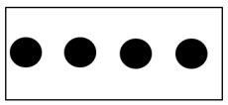 |   crotchet, crotchet rest, quavers in pairs, | 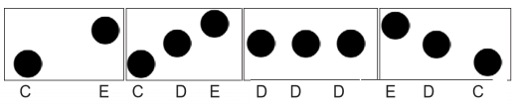  crotchet , crotchet rest , quaver , semiquaver dotted crotchet , quavers in groups of 3 and identical rests in repertoire studied, ostinato | 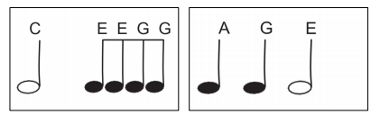  crotchet , crotchet rest , quaver , semiquaver dotted crotchet , quavers in groups of 3 and identical rests in repertoire studied, ostinato | Stick notation within an octave:  crotchet , crotchet rest , quaver , semiquaver dotted crotchet , quavers in groups of 3 and identical rests in repertoire studied, minim, minim rest, semi breve, ostinato | 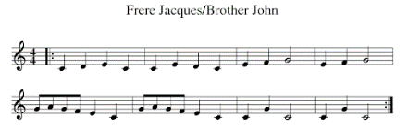  crotchet , crotchet rest , quaver , semiquaver dotted crotchet , quavers in groups of 3 and identical rests in repertoire studied, minim, minim rest, semi breve, ostinato

